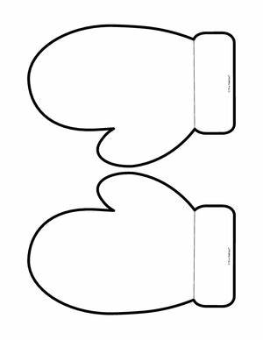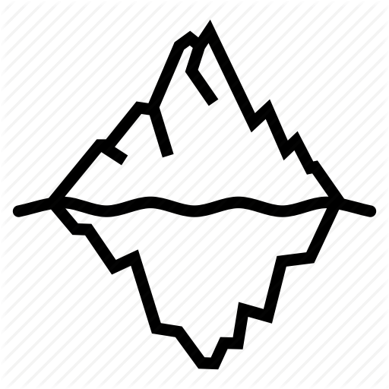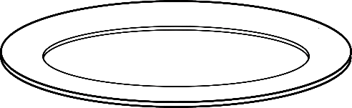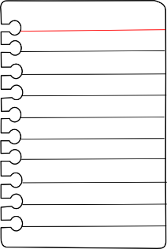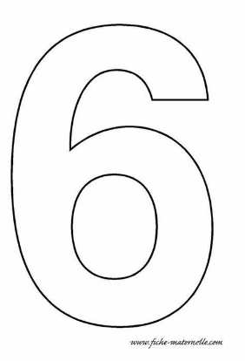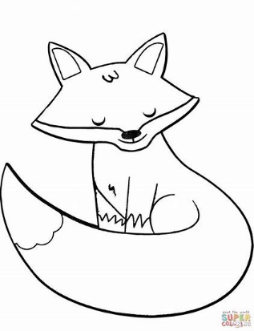

ᐱ

ᐸ

ᐳ

ᐸ

Pictures that start with **/ᐱᐳᐸ/** and  out the pictures that don’t: